SOLENT UNIVERSITY

MSc COMPUTER ENGINEERING

**AJAZALI SAIYED**

**COM712 NETWORKING**

**WARREN EARLE**

**1ST SEPTEMBER**

# Part 1

**RQ1: If layered network reference models are applied to implementing the network of routers and switches and end devices does this assist the network engineer?**

Layered network reference model may be defined as the conceptual framework, which gives a well-organized process for the communication in the network or among the devices. Basically, the layered approach of networking models was developed to deal with the changes in the network, technology, environment etc. Each layer is responsible for different functionality in the communication or in network. By using a layered network model, message, or information passes from one layer to the other. It can be in an upward direction or in a downward direction. The layered approach helps network engineers in various ways. The layered approach is established in main models in the networking, i.e. OSI model and TCP/IP model. OSI model provides the seven layers to the network engineers, whereas the TCP/IP model provides the five layers to the network engineers. Seven layers of the OSI model are Physical layer, data link layer, network layer, transport layer, presentation layer, session layer, the application layer. Five layers of the TCP/IP are Physical layer, data link layer, network layer, transport layer, the application layer. These models separate the whole process of communication into smaller parts or modules. OSI model helps the network engineers to check which set of the protocol will be used on which layer. Different equipments are being used in building a network. These equipment have different compatibility features. All equipment is not compatible with each layer of the model. It provides various benefits to the network engineers like interoperability, greater compatibility of devices and services, better flexibility in the network, scalability in network design, portability of protocols etc. In this way, the layered reference network model assists network engineers while designing a network efficiently.

* 1. **Perform a literature search relating to the research question above (RQ1) and document the results of your relevant literature in a bibliography.**

In this section, various proposed mechanism related to a layered network model has been presented. In (Haas, 1990), HOPS (Horizontally-oriented protocol structure) architecture has proposed. In this structure, layers are coupled with one another. It helps in removing the problem of unnecessary replication and errors in the network. This mechanism offers the parallelism in the network. Due to which, protocol processing rates have increased. Moreover, it provides a reduction in the latency and processing overheads during communication. So, this proposed mechanism provides various features in the performance of the network. In (*Challenges in IoT Networking via TCP/IP Architecture* 2016), various challenges have been mentioned. The proposed architectural change in the whole system. They have shown that IoT systems are mainly based on TCP/IP protocols. They have mentioned that the TCP/IP protocol stack becomes unfit for the IoT environment. Moreover, various technical challenges are there on applying TCP/IP protocols in the IoT environment. They represent that IP-based solutions are not much efficient and sufficient for IoT applications. This section shows the various results of the corresponding literature search.

* 1. **Write a review of the important literature you have identified in the literature search in 1.1.**

In this section, the whole review of the given literature search in 1.1 is mentioned. Accord ing to the (*Challenges in IoT Networking via TCP/IP Architecture* 2016), there can be many challenges regarding the TCP/IP. There can be many challenges to applying TCP/IP to the IoT networks. It is reviewed that most of the problem arises from the transport layer as well as the network layer. Moreover, application layer protocol, like CoAP, gives some solutions by providing its unique functionality. It helps to cope up with the failures given by the lower-level layers. In (Haas, 1990), it is reviewed that more enhancements are required for the improvement of the performance of the high-level protocols. The proposed architecture is helping in the elimination of OS overheads. But HOPS can be improved further for the better performance in the network.

* 1. **Formulate an approach for documenting, implementing and testing the network addressing of the computer network in figure 1 show and describe this approach appropriately in your assessment submission.**

An easy and most convenient method is used in this designing. With the help of the used approach, effective results are coming. Moreover, the network is providing the best performance during communication. In this section, the whole approach is mentioned, which is basically used in the designing of the given network in figure 1. Mainly four sub-networks are present in this whole design in the network. Those four sub-networks are HQ LAN1, HQ LAN2, Branch IoT LAN, Branch CCTV LAN. The four different network addresses are 172.16.0.0/18, 172.16.64.0/18, 8.0.0.0/8, 9.0.0.0/8. For 172.16.0.0/8 and 172.16.64.0/8, subnetting is being done. The whole addressing for each device in sub-networks is present in table 1.

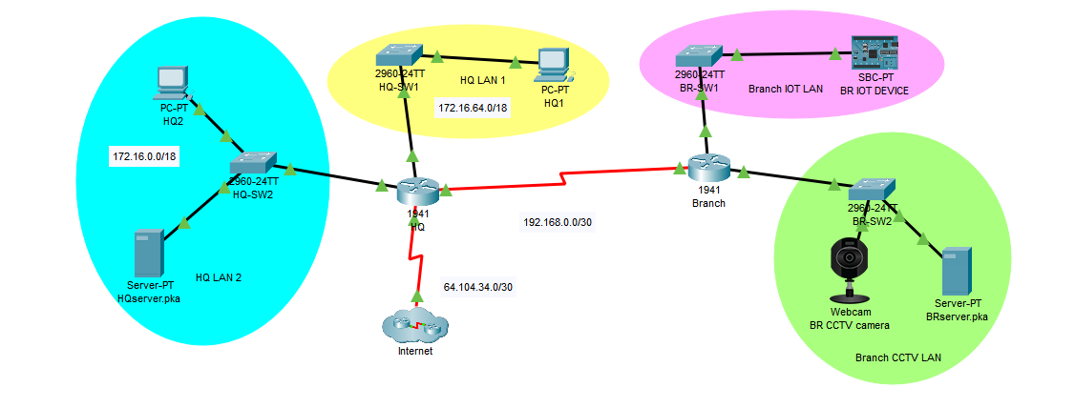

Figure 1: Network Design

The below table is showing overall IP Addressing used in the designing of the network. In this table, IP Addressing of six devices is mentioned, i.e. HQ1, HQ2, HQserver.pka, BR IOT device, BR CCTV camera, BRserver.pka. Each device is having the unique ip address for the communication among one another. Moreover, the subnet mask for each network or device is also mentioned in the below table.

Table 1: IP Addressing in network

|  |  |  |  |  |
| --- | --- | --- | --- | --- |
| **Sr. No.** | **Device Name** | **IP Address** | **Subnet Mask** | **Sub-network name** |
| **1** | HQ1 | 172.16.64.1 | 255.255.192.0 | HQ LAN1 |
| **2** | HQ2 | 172.16.0.1 | 255.255.192.0 | HQ LAN2 |
| **3** | HQserver.pka | 172.16.0.2 | 255.255.192.0 | HQ LAN 2 |
| **4** | BR IOT Device | 8.0.0.1 | 255.0.0.0 | BR IOT LAN |
| **5** | BR CCTV camera | 9.0.0.1 | 255.0.0.0 | BR CCTV LAN |
| **6** | BRserver.pka | 9.0.0.2 | 255.0.0.0 | BR CCTV LAN |

For the connection between the devices, various types of connecting wires are used in the network. The straight-through wire is used for the connection between the two different devices, i.e. router-switch, host to switch, server to switch etc. The serial wire is used for the connection between the two routers, i.e. HQ-Branch. In this whole network, 1941 type of routers and 2960 type of switches are used. Static routing is used in this network for communication among the different networks. Static routing provides many benefits to the network engineers like it eliminates the load on the router’s CPU, it creates on traffic to the other routers, it is the easiest way of configuring routing on the small networks, it provides better performance to the network administrators etc. The below mentioned commands are used for implementing the static routing in the network.

**Router(config)#ip route Destination Network|Destination N/W SubnetMask|Next Hop Address**

For example:

HQ(config)#ip route 8.0.0.0 255.0.0.0 192.168.0.2

HQ(config)#ip route 9.0.0.0 255.0.0.0 192.168.0.2

Branch(config)#ip route 172.16.0.0 255.255.192.0 192.168.0.1

Branch(config)#ip route 172.16.64.0 255.255.192.0 192.168.0.1

After implementing static routing on the network, testing has been proposed. After performing testing, it is clearly analysed that all the messages have reached at the destination successfully. The whole testing is mentioned in figure 2.

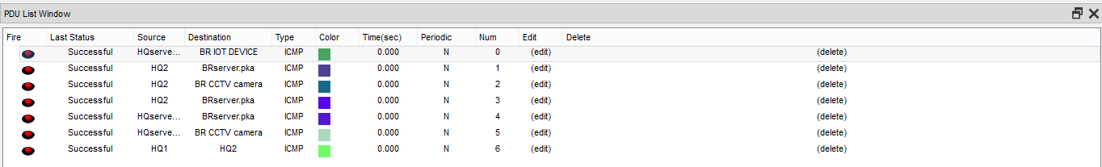

Figure 2: Testing communication

* 1. **Rigorously justify the use of this approach for implementing and testing the network addressing of the computer network in figure 1 by writing a justification in the report.**

In this section, the used approach has been justified by using some commands. Two things have been justified in this section, i.e. route among the devices as well as a routing protocol. In figure 3, routes have been shown. It is mentioned that gateway of last resort is not set, i.e. default route configuration is not set. Various codes are like S, C, L saw in figure 3. Here, S is static, C is connected, L is local. Overall routes are mentioned in figure 3. Routes are shown by considering the subnetting in the network. Moreover, it shows how many subnets are formed in the network. Like in 172.16.0.0/18 and 172.16.64.0/18, 4 different subnets are formed whereas in 192.168.0.0/30(intermediate network address), 64 different subnets are formed.

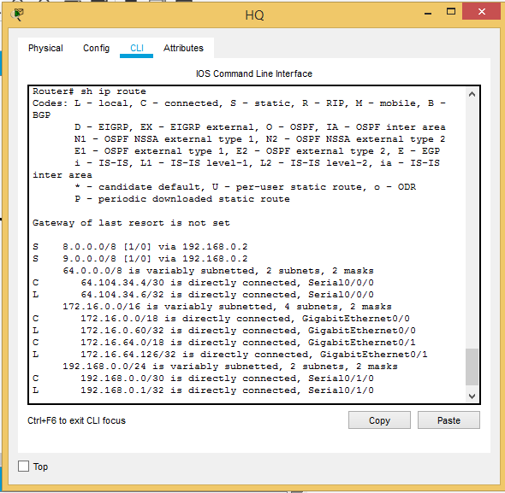

Figure 3: Showing routes in the network

In figure 4, it is justify that internet protocol routing is enabled in the network for the successful communication. Moreover, in this network VLAN is not configured. That’s why it is clearly mentioned that VLAN is administratively down, and the line protocol is down in figure 4. So, these two figures, i.e. 3,4, are giving clear justification for the documented approach.

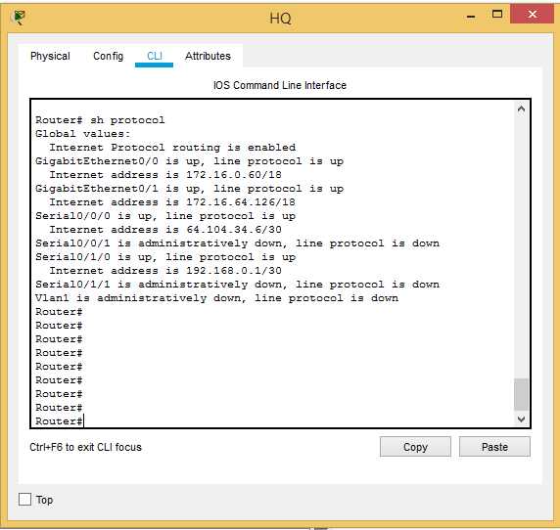

Figure 4: Analyzing protocol

Part 2

**Complete the IPv6 Addressing of the Computer Network**

| **Subnet Description** | **Subnet Id** | **IPv6 Network Prefix /Prefix Length** |
| --- | --- | --- |
| HQ LAN1 | BBBB | 2004:BBBB::/64 |
| HQ LAN 2 | AAAA | 2004:AAAA::/64 |
| Branch IoT LAN | CCCC | 2004:CCCC::/64 |
| Branch CCTV LAN | DDDD | 2004:DDDD::/64 |

| Network Device | Interface | MAC Address | Global IPv6 Address/Prefix Length | Link Local Address |
| --- | --- | --- | --- | --- |
| HQ  BR1 | G0/0 | 0003.E498.9E01 | 2004:AAAA::203:E4FF:FE98:9E01 | FE80::203:E4FF:FE98:9E01 |
| G0/1 | 0003.E498.9E02 | 2004:BBBB::203:E4FF:FE98:9E02 | FE80::203:E4FF:FE98:9E02 |
| Branch | G0/0 | 0001.632C.B901 | 2004:CCCC::201:63FF:FE2C:B901 | FE80::201:63FF:FE2C:B901 |
| BR2 | G0/1 | 0001.632C.B902 | 2004:DDDD::201:63FF:FE2C:B902 | FE80::201:63FF:FE2C:B902 |

| **End Device** | **MAC Address** | **IPv6 Device Address /Prefix Length** | **Link Local Address** |
| --- | --- | --- | --- |
| HQ1 | 00D0.BCDD.315B | 2004:BBBB::1/64 | FE80::2D0:BCFF:FEDD:315B |
| HQ2 | 0060.473E.585C | 2004:AAAA::1/64 | FE80::260:47FF:FE3E:585C |
| HQserver | 0060.47C8.7111 | 2004:AAAA::2/64 | FE80::260:47FF:FEC8:7111 |
| BR IoT Device | 00D0.58A6.7034 | 2004:CCCC::1/64 | FE80::2D0:58FF:FEA6:7034 |
| BR CCTV Camera | 0060.5CDD.DE36 | 2004:DDDD::1/64 | FE80::260:5CFF:FEDD:DE36 |
| BRServer | 0030.A328.56A0 | 2004:DDDD::2/64 | FE80::230:A3FF:FE28:56A0 |

**Work Cited**

Haas, Z. (n.d.). A communication architecture for high-speed networking. *Proceedings. IEEE INFOCOM '90: Ninth Annual Joint Conference of the IEEE Computer and Communications Societies@m_The Multiple Facets of Integration*. doi:10.1109/infcom.1990.91279

W., & Y. (2016, February 10). *Challenges in IoT Networking via TCP/IP Architecture*.

Layering Concepts and Benefits. (2019, March 28). Retrieved August 24, 2020, from <https://www.vskills.in/certification/tutorial/basic-network-support/layering-concepts-and-benefits/>

Admin. (1970, January 01). How to Configure a Simple Static Routing in Packet Tracer. Retrieved August 24, 2020, from <https://www.chennaicisco.com/2013/01/how-to-configure-simple-static-routing.html>

Static routing. (2020, July 25). Retrieved August 24, 2020, from <https://en.wikipedia.org/wiki/Static_routing>